Columnar Databases: Cassandra

# Set up

Set up Python 2.7 and enable it in current shell.

$ sudo yum install -y centos-release-scl

$ sudo yum install -y python27

$ scl enable python27 bash

Download Cassandra tarball.

$ wget http://apache.lauf-forum.at/cassandra/2.2.14/apache-cassandra-2.2.14-bin.tar.gz

Untar the file.

$ tar -xvf apache-cassandra-2.2.14-bin.tar.gz

Add the bin subdirectory into $PATH.

$ PATH=$PATH:/home/cloudera/apache-cassandra-2.2.14/bin

Start Cassandra daemon. There will be much output, shouldn’t be any errors.

$ cassandra

Verify that it is running.

$ nodetool status

Output should be like this.

Datacenter: datacenter1

=======================

Status=Up/Down

|/ State=Normal/Leaving/Joining/Moving

-- Address Load Tokens Owns (effective) Host ID Rack

UN 127.0.0.1 169.05 KiB 256 100.0% ac401622-b894-47a9-a31b-e1f364adeaff rack1

Copy your own output here:

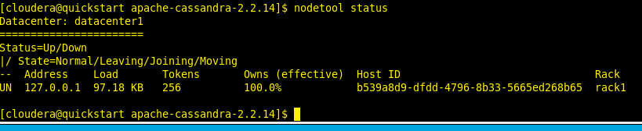

# Prepare the data

Download stock exchange dataset

$ wget https://s3.amazonaws.com/hw-sandbox/tutorial1/NYSE-2000-2001.tsv.gz -O - | gzip -d > NYSE-2000-2001.tsv

Cassandra uses an SQL dialect called CQL that allows to the users familiar with SQL to start operating in a very short amount of time. The Cassandra equivalent of a database as outermost grouping unit for data is called keyspace.

Open the cqlsh.

$ cqlsh

Create new keyspace.

cqlsh> CREATE KEYSPACE stock_exchanges WITH replication = {'class': 'SimpleStrategy', 'replication_factor': 1};

Create a new table with partition key of (exchange, stock_symbol).

cqlsh> CREATE TABLE stock_exchanges.nyse

(exchange text,

stock_symbol text,

date text,

stock_price_open float,

stock_price_high float,

stock_price_low float,

stock_price_close float,

stock_volume float,

stock_price_adj_close float,

PRIMARY KEY ((exchange, stock_symbol), date));

# Import the data

Import it using cqlsh.

cqlsh> COPY stock_exchanges.nyse (exchange , stock_symbol , date, stock_price_open, stock_price_high,

stock_price_low, stock_price_close, stock_volume, stock_price_adj_close)

FROM 'NYSE-2000-2001.tsv'

WITH DELIMITER='\t' AND HEADER = 'true';

Copy here the output of the command:

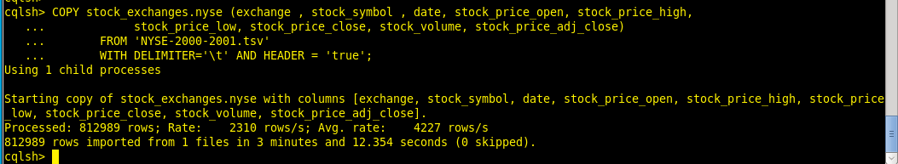

# Query the data

Select the first five opening prices belonging to a specific ticker from the cqlsh.

cqlsh> SELECT date, stock_price_open FROM stock_exchanges.nyse WHERE exchange = 'NYSE' AND stock_symbol = 'ASP'

LIMIT 5;

Copy and paste text output or screenshot of at least first 5 lines here:

